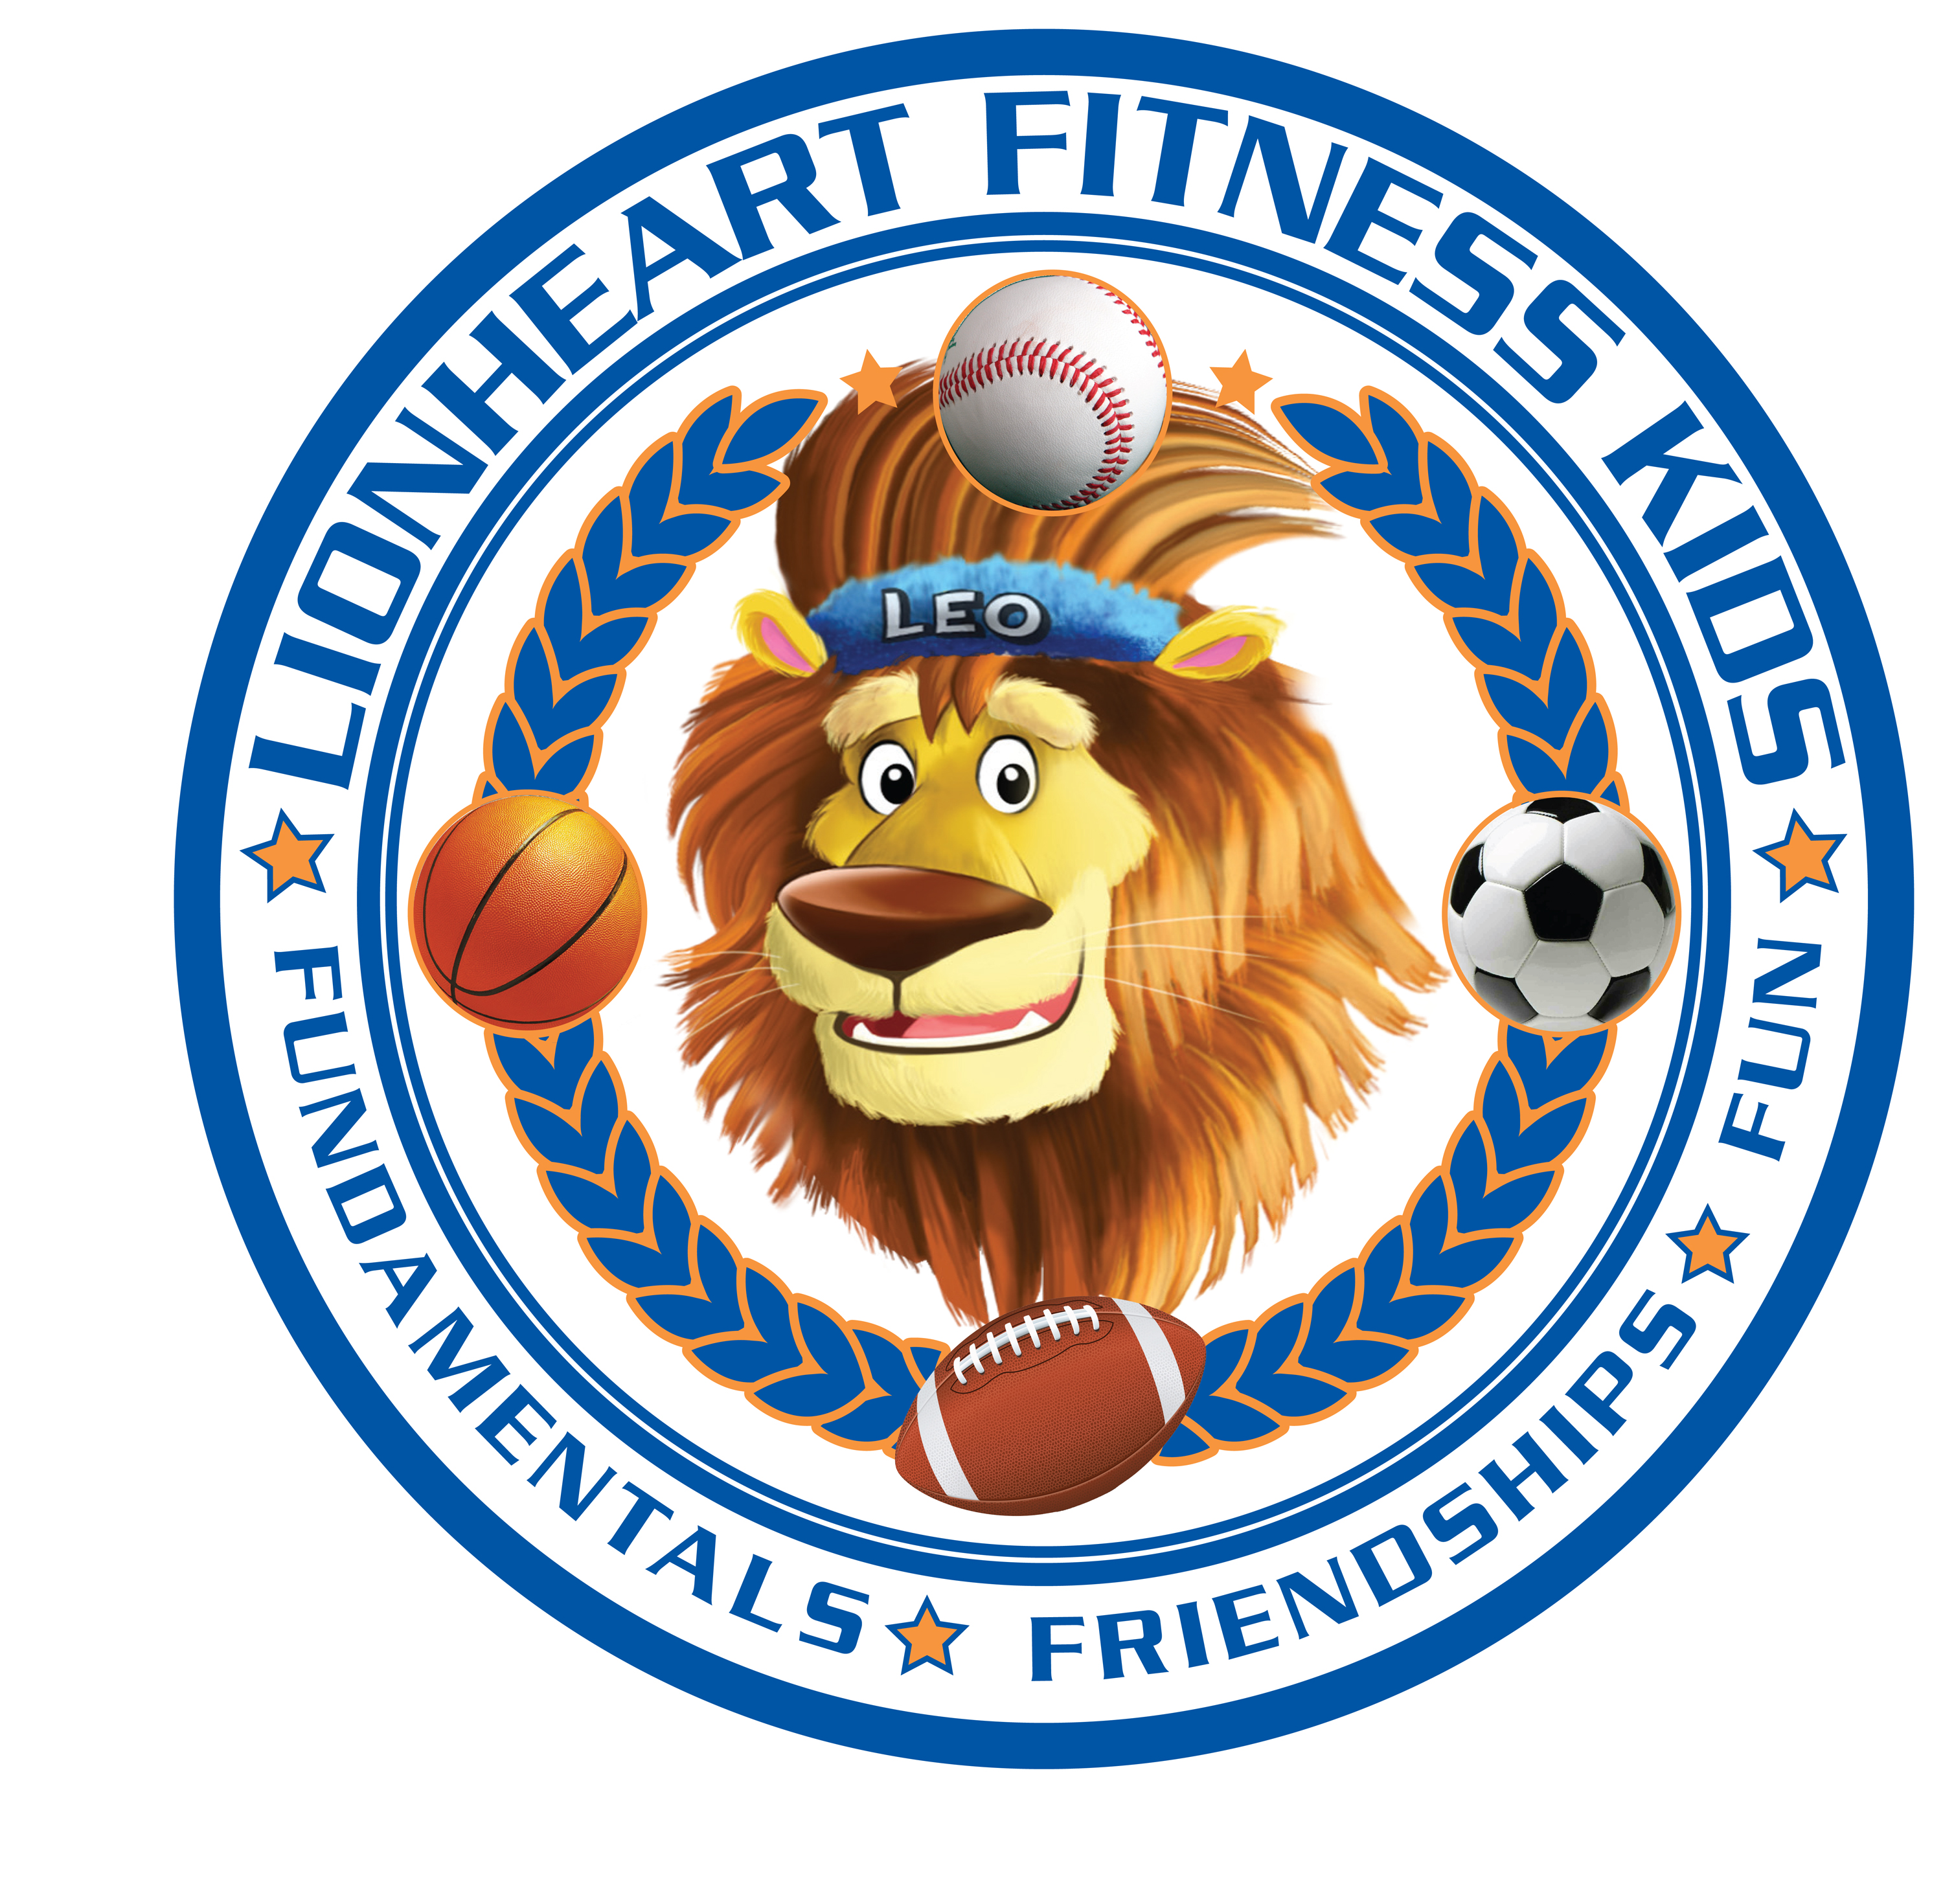
Who we are- Established in Sept 2008 Lionheart Fitness kids began with a single class of 7 children. Our goal was simple; to teach the fundamentals of sports in a fun, stress free environment and above all else put the children first. Today Lionheart is a national company over 20,000 strong and counting!
Mission- At Lionheart Fitness Kids we strongly value the limitless potential of a child. Given the necessary tools to succeed there is nothing they cannot achieve. It is our mission to empower children through physical fitness, giving them the skills, confidence and positive self-image to take on any challenge. This is our promise and we are committed.

Complete School Year Schedule- 5 wk sessions of the following sports. 45 min classes 1x per week.

Baseball, Soccer, Basketball, Flag Football, Track & Field, Volleyball, Gymnastics, Field Hockey.
Coaches/Ratio: All classes are staffed by a fully qualified fitness coach. If the class exceeds 15 children we split the classes up to ensure quality of instruction. Coaches are LFK certified and trained in each specific sport. Lionheart Fitness Kids employees are fully screened and background checked.
Cost: $85 per 5 week session. This includes achievement stamps after every class and a special award at the end of every 5 week session. We provide all the equipment as well.

Check our website out at www.lionheartfitnesskids.com
Check our video out at https://youtu.be/DXbzdou9o7o

Contact Info:

Zach Trevor

Ph:415.299.0202

Email: Zach@lionheartfitnesskids.net

Call now to set up your FREE demo!

